BODIES IN THE FOLD: THE POET ARTISTS TO MEND THE SOCIAL

Zahra Babaei
The Body in South Asian Art, c. 1993
Professor Meghaa Parvathy Ballakrishnen
December 2025
List of Figures
Figure 1. Arpita Singh, My Mother, 1993.
Figure 2. Arpita Singh, Lot 1040, 1971.
Figure 3. Arpita Singh, Untitled, 1981. Poster paint on paper, 26.75 × 34.75 inches.
Figure 4. Seher Shah, The Dacca Gauzes, 2024.
Figure 5. Arpita Singh, Munna Apa’s Garden, 1989. Oil on canvas.
Figure 6. Arpita Singh, My Lily Pond, 2009. Oil on canvas, 48 × 108 inches.
Figure 7. Bhupen Khakhar, You Can’t Please All, 1981.
Figure 8. Bhupen Khakhar, The Sweet Smell of His Hair Oil, 2002. Watercolor on paper, 29 × 19 inches.
Figure 9. Bhupen Khakhar, You Can’t Please All (detail), 1981.

Abstract
For this paper 1993 marks a crucial point. In India, it was a year of upheaval and bodily destabilization. It is also the year Gilles Deleuze published The Fold, a text that reinterprets Leibniz’s Baroque philosophy of folds. While retaining Leibniz’ monadic frames, Deleuze’ take becomes more of a formal analysis of the fold as a cosmological infinitude of matter, a shared quality between nature, bodies, objects, organic or inorganic. As much as Leibniz considers unity within all phenomena, he rarely ever considers ruptures. As the fold happens metaphysically, it is incapable of considering the flesh. Throughout this paper I ask if the body may be a metonym for pleats of matter. What happens when the body itself becomes ruptured? When a monad no longer sways with the cosmos?
My paper brings wounds, tears, disasters, split identities, and exilic subjectivity to its center, to look at art practice along that take poiesis as a mode of knowledge production. Poiesis centralizes a mode of making that produces knowledge through form, material, and embodied practice rather than through universal abstraction. In this regard I discuss the Indian artists Arpita Singh and Bhupen Khakhar and look at their oftensimilar worldmaking and how they bargain with the limits of their mediums. Looking at the way they treat objects as stand-ins for a historical moment, such as Bombay riots, leading to the demolition of Babri Masjed, I see how their work enlarges the discontinuities of human experience into the everyday objects as they wrap a larger sociopolitical rupture into their folds.
While Universalism presumes intact monadic structure, colonial history leaves wounded, ruptured bodies; therefore, the fold must be rethought through poiesis, not metaphysics. In this paper, I would argue that Leibniz’s monad has an interiority only in the most metaphysical, deracinated sense; it does not and cannot account for the historical interiority of colonized or wounded subjectivities. Although the artists I’m going to discuss had the least concern about representing a wholistic view to the social realities of their time, their work can speak to the condition of modernity much more deeply than any universalist philosophy.
The Universal Fold
In his Discourse on Metaphysics, Leibniz, offers a new form of articulating the relationship between the individual and the cosmos. He considers everything, including humans, as consisting of continuous matter that and moves from one to the other as folds. He uses the metaphor of a garden or a pond full of fishes where each drop of its liquid parts is also some such garden or pond. Yet in discussing Arpita’s work, the same natural figures seem to appear as a site of terror, no longer a unifying motion and in fact a space of tension through historical associations. This is not the mere pond nor garden but the desire to map an internal motion into a universal pond. This desire for continuity in Leibniz, turns into a fear for Arpita, as she has seen what the assumptions of an all-encompassing theory for human experience could result in. Instead, she has found personal takes of historical events that has introduced a commotion to the order of human history to insert new subjectivities into it.
Her neighbors, acquaintances, and their memories become the subjects of her paintings. Being part of a community of artists in Baroda, she turns her canvas into a stage for an incommensurable history. Arpita traces out an assemblage of human and nonhuman actors, binding together intensely disjunctive components: cars, genitals, curtains, organs, household object, animal, texts and moral commands. For her staged narratives of violence humans and nonhumans work together to engineer chains of cause and effect that turns the visual to the rebel yoking and merging of disparate worlds; the split statue juxtaposed to a bicycle moving across the canvas slitted by a diagonal road. (Figure 1)
Arpita’s painting forges ties between symbolism and experience, of memories shared between humans, objects, art, myths. Rather than being graspable via a single point of view her painting reassembles singularities from multiple worlds. They slice across divisions of thought/matter, subject/object, history/memory, sacred/profane, human/animal, and bringing differing modes of being into the plane of coexistence.
There is, then in My Mother, the object itself appearing against us, as an emblem of its time. Rather than being used and discarded, they have become hindrances to their own commodity and use, carrying signs of violence, and rupture. This is a clear inclusion of an etymological root of the word “object” to affectively counter its use. From objecten, meaning “to bring forward as a ground of opposition, doubt, or criticism; to raise an argument against” Arpita’s object contains this antagonism in their visual etymology. In this sense, her objects suspend continuity and harmony understood as an “obstacle” or “hindrance”, in the trajectory toward which a cognitive act is ordinarily directed. In My Mother, she has turned the canvas into a map of such hindrances; an everyday object turned into evidence that bares how the state chooses its targets.
Through her relationship with craft, Arpita maintained a “symbiotic relation” to objects. As Deepak Ananth observes in Profound Play, she belongs to a generation of artists that still sustained a reciprocal connection with “the métier of the weaver, the potter, the blacksmith.” This material intimacy can be partially attributed to her experience as an artistic consultant for the Handloom Board, where she worked extensively with textiles, studying traditions of cloth-making, embroidery techniques, and the structural logic of drapery. This becomes visible in her drawings from 1975–79, where she introduces a translucent net curtain across the pictorial sky. As Geeta Kapur notes, Singh here “fuses the structure and support,” as a “playful allusion to illusionism.” (Figure 2)
The use of a grid as a concluding gesture of modernist obsession here modified by the curtain as a feminnie gesture of the fusion of function and form via ornament. The curtain develops an epic dimension of the event, as the secne behind its acquire an extraordinary dimension. Thus Arpita’s paintings make possible an exchange of the usually-male protagonist of culture to a feminine interiority. This engagament with textile anticipates her 70’s and early 80’s work that could be read as an asbtraction of fabric in stitches, lines, and tears.
In her 1981 painting Untitled (figure 3), the repetition of lines, often disrupted, conjures the partially automated movement of weavers’ hands. Lines begin to disentangle as they move toward the middle of the work, where they reach an open, empty surface of the paper. The upper and lower edges of this work retain the same structure, but the flow of incongruous lines in the middle starts to inhabit a new form of matter. It forms a cluster of worm-like shapes made into border swollen with lines. Although these era of her work do not easily fit into her figurative world-making but comes as a form of personal abstraction of the post-Partition social fabric, mending the mundane art of textile and the language of abstract art.
Considering the language of abstraction, Seher Shah is another contemporary artist that comes to mind. The connection between poetic abstraction and visual practice is mostly apparent in a series Seher made, titled Dacca Gauzes, influenced by Agha Shahid Ali’s poetry with the same title. Looking at one of the works in this series, Dust and Woven Air, (figure 4) there’s a pattern of an unformed language stripped down to repeating Alephs and dots on mechanically drawn lines. Her photogravures on cotton thus mentally map material and linguistic ruins. As much as the forms here precedes meaning – as they don’t correspond to our linguistic knowledge – their calligraphic form demands reading. The movement of her hand, in its ascending and descending, while mimicking Urdu’s calligraphic style, makes no concrete word; they form lines that resemble alphabets but only in a formal sense. The figure of the “amputated hand” in Agha Shahid Ali’s poem, seems to have been affectively involved in shaping these forms. As the words themselves have been amputated, they have only retained a rhythm giving away the meanings to the translation. Amputation is an active force in translation; what translates is able to reach the other side and what remains are disjointed fragments of words that never made it. Translated language seems in this way ruptured from its material origin and the possibility of weaving it back remains in the hands of the weaver.
The weaving for Arpita’s practice is not that of bringing together everything to a singular vanishing point, but to create a discontinuous space with every object ‘s capacity to have its own spatial exclusivity. This continues as a thread in her later work, in her treatment of the painting surface that rejects illusive depth and remains faithful to the upright space of the canvas; a world that turns entirely toward us. (Figure 2) It is in her nonhierarchic approach that we see a directness in her paintings, which may at first appear as “childlike” as Deepak Ananth defines it, but the “childlike” here is to be understood not as naïveté but as a democratic vision that refuses to subordinate imagination to the foreshortening of realism.
By paralleling Arpita with “earlier modernist painters” like Klee and Chagall, Ananth defends Indian art’s “delayed modernity” through the condition of the postcolonial subject. Here, I drift away from his argument to consider belatedness as a kind of bending toward a one-sided narrative of modernity that suspends the time of those who have not been “on time.” In the procession of Western periodization, the “belated” becomes the “backward,” and art comes only to accessorize a visual timeline. Arpita’s relationship to time however refuses this linear history and remains faithful to those timelines that has never been inserted into the saga of modernity; she instead lays out for us a collage of things that no history contains as they themselves made into vessels of time.
“The childish playlet might include anything,” Ananth writes, “from ducklings making free of the living room transformed into a pond” to planes taking off and cars with scale-discordant figures, all cohabiting the immobile interior surface of the canvas. Like a pond’s surface, Arpita’s canvases are a shared screen between simultaneous events, each unfolding at different depths and heights: the sky, the underworld, and her floating figures. There may be little use in connecting the etymologically unrelated pond to pondering, but both are at work when one arrives at her 1989 Munna Apa’s Garden (Figure 5), that refuses to make any hierarchical placement of those who inhabit its surface. Here, Arpita cites Munna, who witnessed the violence of Partition in her teenage years first-hand. But we seem to have arrived late; the planes have left, the cars are full, and those who had been waiting for us are gone.
The blue in the background offers no distinction between water and sky but becomes both. After Partition, water could no longer hold myths as its flows were reterritorialized. In arbitrating the border between India and Pakistan in 1947, Sir Cyril Radcliffe, the chairman of the bodies set up to define the borders, could not decide what to do with the Indus River system, given that it was likely to be vital to both states. The vitality of water, as much as it was invoked in the myth of nation-building, was disregarded in the early days of Partition. India, at the time of the sowing season, shut off the Central Bari Doab Canals, causing significant damage to Pakistan’s crops and exposing a central weakness and vulnerability in the newly created state. The water in Arpita’s work similarly has a dubious character. It is never clear whether the blue is water or mirage, or whether the figures inhabiting its surface are dead or alive.
In 2009, Arpita’s My Lily Pond (figure 6), the relentlessly repeated word “water” forms a surface that is anything but what the title of this large triptych would lead us to imagine. The triptych seems to occupy a numerical code of reading directionality that could be read as a sequential turn in her paintings. Unlike her usual nonlinear approach this time we are given instructions for reaching the truth; it is the exactitude of violence that forecloses the imaginative possibilities of the alternative. Our aerial view tends to imagine a sky reflecting on the water but as each figure repeats clashes our formal expectations into the water that is no longer a space between sky and ground for an artistic plot twist but alphabetically distinguished from both. The numbered sequence seems to have in its formal construction an evidentiary purpose that mimics official documents; which a quote at the upper right corner of the third sequence comes to manifest for us; the “truth.” This dubious representation of truth in Arpita’s painting brings us to another Baroda school painter, Bhupen Khakhar, whose theatricalization of reality has a similar uncertainty as her “playlets”.
The space of Bhupen’s paintings concerns a sequential layering that holds events, narrators, and the spectator into each of its folds while keeping a transcendental gap open. The figure of water in You Can’t Please All (figure 7) seem to contain in itself everything that the paintings seem to communicate. The water reflects a sky that its harsh blue is nowhere near the actual sky in the painting, a dubious production of reality with a possibility of an inaccessible offstage. Khakhar use of film references makes us sure of this ‘double reading’ that his spectators recognize through another onlooker in the painting who signals “where” to look at, and “how” a normative imaginary observer is supposed to comprehend the scene. As Ashish observes Khakhar gives this easily comprehended Brechtian spectator a particular place that the theatrical-effect would inherit and replicate.
This theatricality for Bhupen is often facilitated in the appearance of a curtain as the rolled-up fabric in You Can’t Please All exemplifies as it introduces a distance. Curtaining in this painting seems to be a strategy of representing the theatricality of the everyday that reprises the inside and outside. It denounced the illusion of the real as this theatrical accessory has made clear the dread of the attempt confuse hidden and the spectacle. Its role consists in recalling their scission and, consequently, to play with it.
On a stage or on a canvas, the curtain unrealizes everything and installs the reign of representation. It annoys insofar as each time it intervenes it recalls that the world is a theater with predetermined behaviors, assigned roles and limited to interpretations. Because it rises for a hypothetical spectator and falls on an actor, it refers to the visibility of a life conscious of its theater and resigned to its repetition.
Here the theatricality does not appear through the intrusion of the gaze on the contrary, it is allowed by the staged, elaborated, scene that welcomes interference. The curtain is nevertheless not public, since it is inscribed, a private space reserved for the invited spectator. It is for him that the curtain ceases to separate; it installs a communication between the allegory of painting and the gaze that is indispensable to it. As the curtain appears usually on a margin, at the edge of two spaces, his space seems to have been separated from two sides, one through the hanging blanket on the porch and the other from us. In this way, he seems to have at a stage for us the cusp of his private life with a performative separation from the outside that climaxes the secrecy of the everyday. Referring to a famous folktale, he oversees the people as a didactic theater, yet he does not separate himself fully from it.
References to his homosexuality, which he openly acknowledged from 1981 onward, seems to have been the possibility of a revelatory action that the curtain has already set its stage. New possibility for the life of a marginalized man to be included in a national narrative. You Can’t Please All then marks the appearance of a sociality that although diverges from its social expectations seems to have reclaimed it through the vernacular.
The curtain undergoes this pressure and gives to read the disorder of the relations that the inside maintains with the outside. Using this curtain, Bhupen’s painting produces a margin that performatively separates the character from society only to merge with it on a shared canvas. Since this separation is mostly a narcissistic one, the communication between the two is not suspended. They remain close to each other to preserve the possibility of their exchange, or even their reciprocal conversation that Bhupen’s addition to the vernacular story seems to be one. In a slight distortion of the same story, he introduces auto-eroticism as a form of fulfillment of a social desire, one that seems to be buried for the everyday man under his porch. (Figure 9)
In another painting, the sensual nature of a connection with the common man, forms an excessive sexuality that curtain, again, comes to signify. Appearing above the canvas like a code for an intimate entrance, the wavey structure of the curtain covers the harsh edges of the architecture in The Sweet of Smell of His Hair Oil. (Figure 8) Continuous in the barber and the seater’s clothes in a seductive transparency, wrinkles and folds appear as they emasculate the homosocial bonds against what that the barbershop traditionally accommodates. It is to Bhupen’s mischievous interventions that the life of the everyday man seems to show a sensuous flexibility to the possibility for change. Same plasticity manifested in the curtain gives the possibility of this scene freed from its architecture; without spatial particularity, a utopia has made possible in the touch of the ordinary man.
In Bhupen’s paintings, architecture serves as a covering, a makeshift structure between the skin of society and the common man’s incongruous touch. His figures require these coverings to hide an excess of their bodies and desires, and the thin walls come to mediate their private lives for the anxiogenic public. Bhupen, without fully exposing these scenes, stages an interior that theatrically frames the outside through them. The society serves as a backdrop to the private activities of his characters.
In slitted walls and interiors that perform secrecy yet reveal as much as they hide, Bhupen shows an equal attention to the personal and official in fragments and panoramas. His paintings thus register a complicated structure within the narratives of modern India, one that unfolds not only on national or historical scales but also between two men sharing the same blanket. Cohabitation here does not require unity or oneness; rather, it demands compassion for difference and a careful handling of disunity itself. Bhupen, in this way, creates the possibility of suturing disjunctions through liberated forms of bodily and often libidinal coexistence.
Understanding society as a cohabitation of different groups, we can see how this neighborhood effect can lead to a transformation of the actors responding to the others’ movements. Emotions, because of such movements (from the Latin emovere), are then interdependent responses to the external world as we move and are moved by it. It is here that a return to Leibniz becomes necessary, if only to mark the limits of his monadic model. For Leibniz, the changes of the monad arise from an internal principle alone; external forces, he insists, “can have no influence upon their inner being.” Such an intact interiority presumes an isolating logic that cannot account for social life as it is lived through permeability, vulnerability, and historical pressure. A wounded or marginalized subject does not experience the world as a harmonious fold but as a series of ruptures that constantly traverse the boundary between inside and outside. To imagine the interior as untouched by the outside is to deny how bodies are shaped by violence, marginalization, desire, and care.
It is precisely here that artists and poets intervene. By giving form to the interior, by making it tactile and external, they allow society to encounter itself. In Arpita Singh’s mischievous reconfigurations of reality, we do not receive a comprehensive account of historical events, but fragments filtered through lived experience. Her paintings disclose how a time was endured, but do not present themselves as a historiographic document. Unlike the historian, whose reliance on citation and pre-existing discourse often forecloses interpretation by positioning the reader within an authoritative framework, these painters cite otherwise.
In Munna Apa’s Garden, Arpita’s citation of Munna is neither factual nor explanatory but comes with its ambivalences, with a momentary possibility of being shared, a conjoined vision between narrator and painter that remains open to interpretation.
What emerges across these practices is a renegotiation of the fold itself. No longer a metaphysical principle of seamless continuity, the fold appears as a site of continuous transformation. Singh and Khakhar’s work, instead of insisting on a harmonious abstraction of reality, carefully negotiates division. In doing so, they propose an alternative social imagination in which wounded bodies, minority histories, are no longer incongruities, but the very grounds from which the social can be rethought.
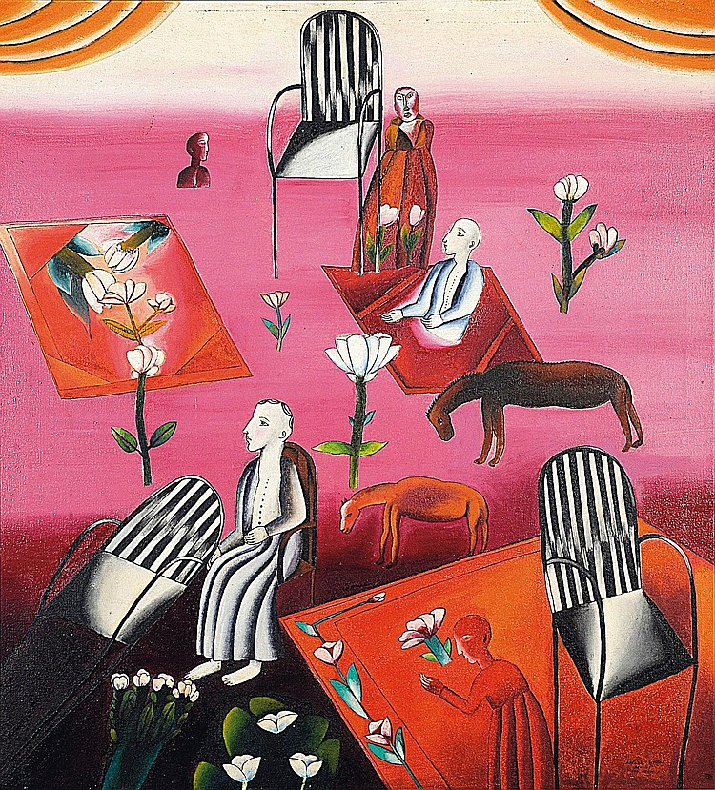
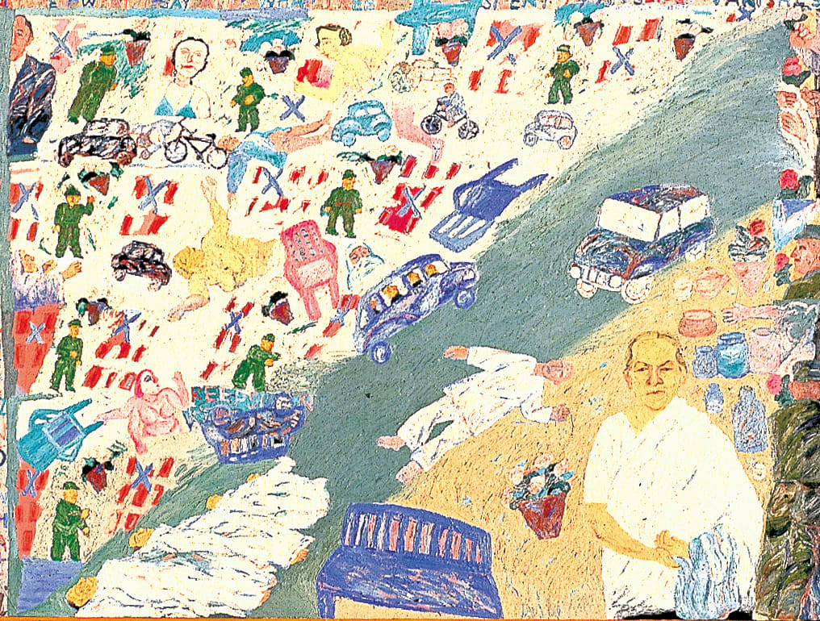
Figure 1: Arpita Singh, My Mother, 1993
Figure 2: Arpita Singh, Lot 1040, 1971

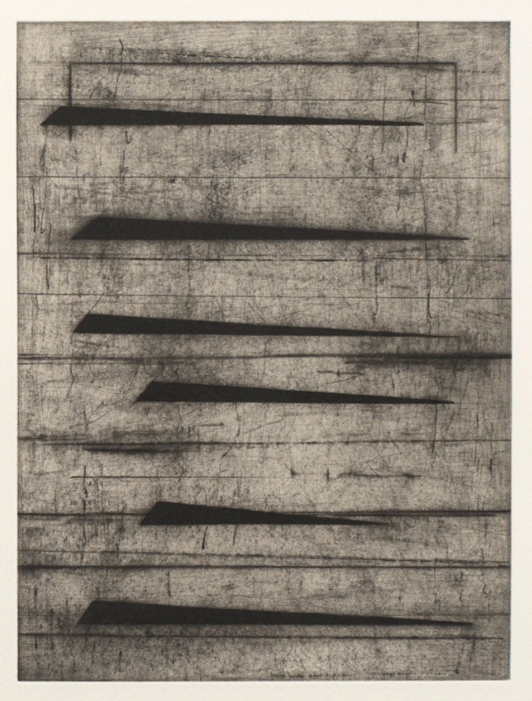
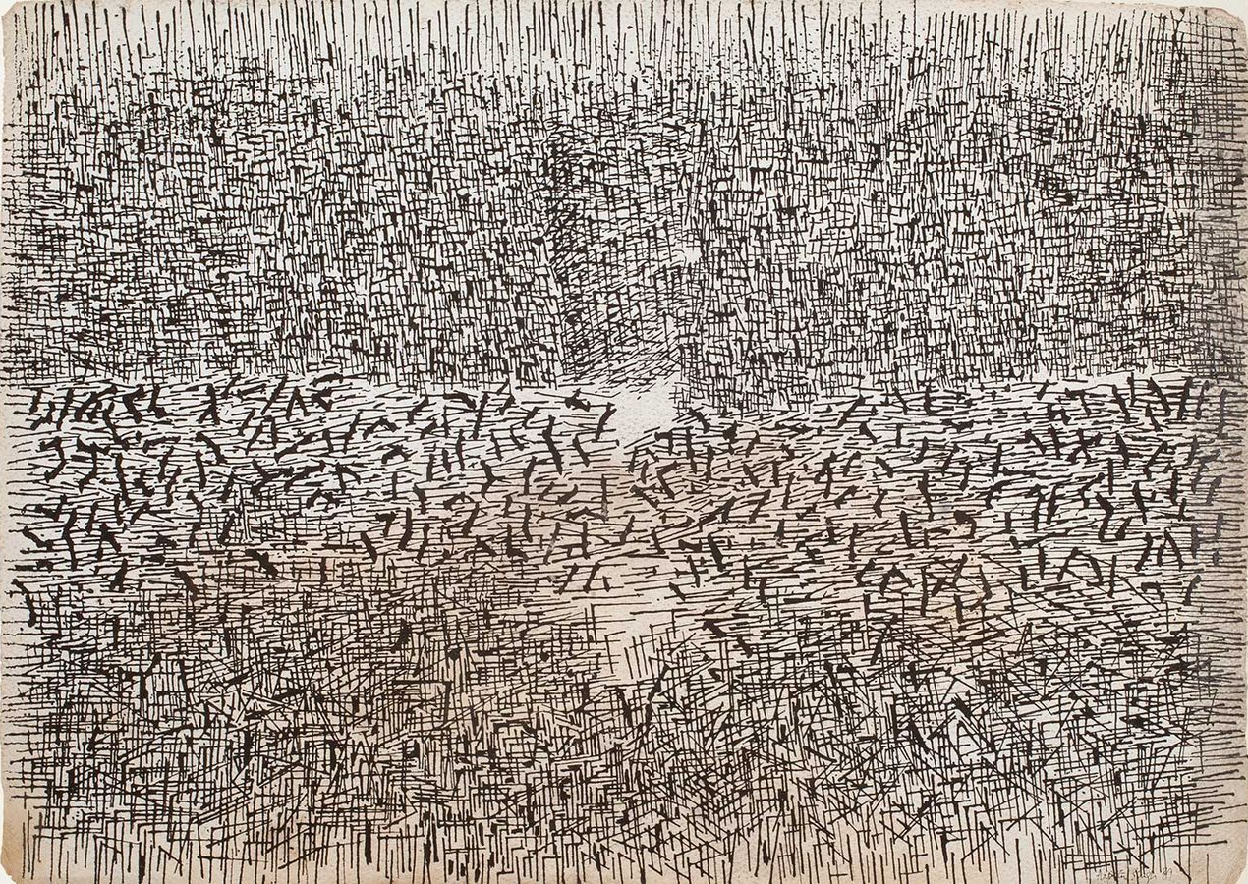
Figure 3: Arpita Singh, Untitled (1981), Poster paint on paper, 26.75″ x 34.75″
Figure 4: Seher Shah, The Dacca Gauzes, 2024.

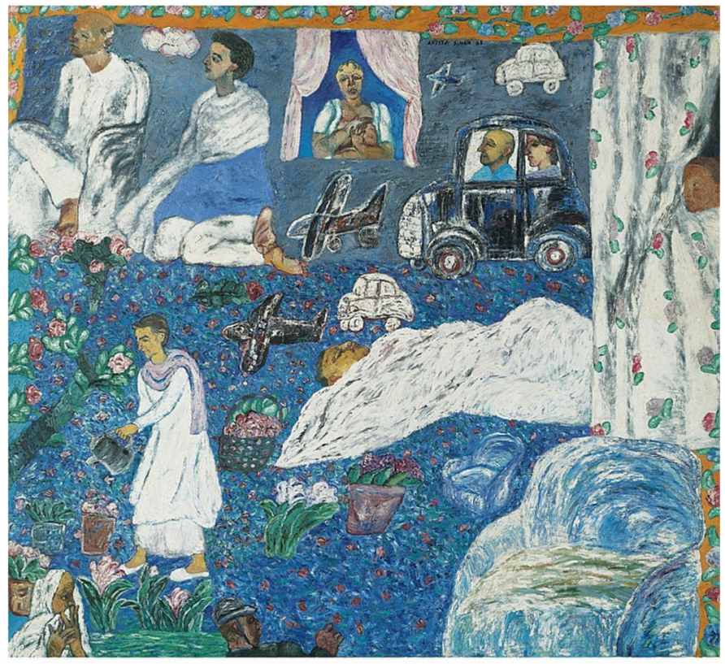
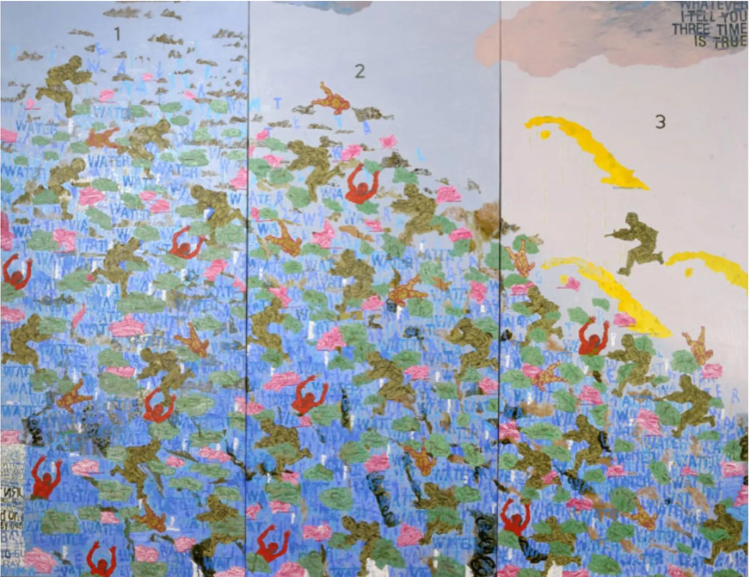
Figure 5: Munna Apa’s Garden, Oil on Canvas, 1989
Figure 6: My Lily Pond, Oil on canvas, 4" x 108", 2009

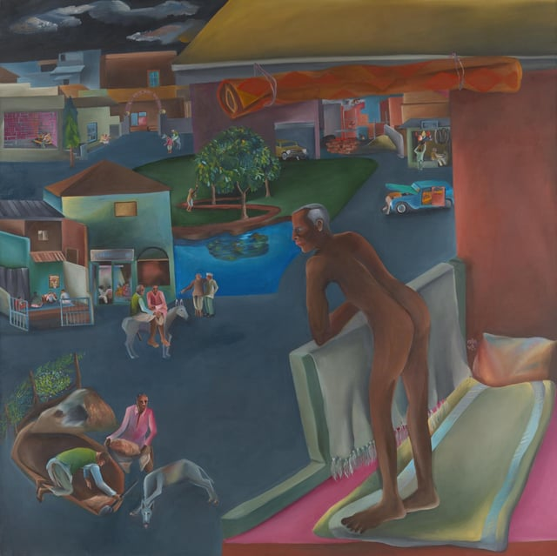
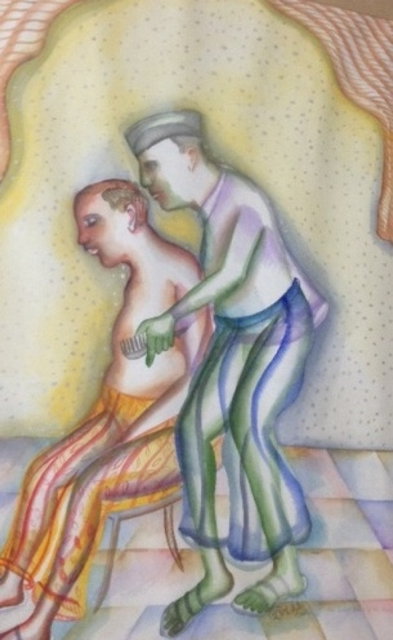
Figure 7: Bhupen Khakhar, You Can’t Please All, 1981
Figure 8: Bhupen Khakhar, The Sweet Smell of His Hair Oil, Watercolor on Paper, 29 x 19 inches, 2002
Figure 9: Bhupen Khakhar, You Can’t Please All (detail), 1981

Works Cited
Ananth, Deepak. Profound Play: Arpita Singh. New Delhi: Penguin Books India and Vadehra Art Gallery, 2015.
Ashish Rajadhyaksha. Indian Cinema in the Time of Celluloid: From Bollywood to the Emergency. Bloomington, Ind., Indiana University Press; Chesham, 2009.
Banu, Georges. Le Rideau Ou La Fêlure Du Monde. Adam Biro, 1997.
Bhabha, Homi K. The Location of Culture. London: Routledge, 1994.
Breger, Claudia. Making Worlds: Affect and Collectivity in Contemporary European Cinema. Columbia University Press, 2021.
Corbin, Henry. “Mundus Imaginalis, or the Imaginary and the Imaginal.” Spring, vol. 1, 1964, pp. 1–19.
Felski, Rita. Hooked: Art and Attachment. University of Chicago Press, 2020.
Jauss, Hans Robert, and Michael Shaw. “Poesies.” Critical Inquiry, vol. 8, no. 3, 1982, pp. 591–608.
Kant, Immanuel. Critique of Pure Reason. Translated by Paul Guyer and Allen W. Wood, Cambridge University Press, 1998.
Kapur, Geeta. “Body as Gesture: Women Artists at Work” in Representing the Body: Art History and Gender, edited by Vidya Dehejia, Kali for Women, Delhi, 1997.
Leibniz, Gottfried Wilhelm. Discourse on Metaphysics. Translated by George R. Montgomery, Open Court Publishing, 1902.

Ananth, Deepak. Profound Play: Arpita Singh. New Delhi: Penguin Books India and Vadehra Art Gallery, 2015.
Kapur, Geeta. “Body as Gesture: Women Artists at Work” in Representing the Body: Art History and Gender, edited by Vidya Dehejia, Kali for Women, Delhi, 1997.
Ali, Shahid. “The Dacca Gauzes,” from The Veiled Suite: The Collected Poems. New York, W.W. Norton & Co, 2009.
Ananth, Deepak. Profound Play: Arpita Singh. New Delhi: Penguin Books India and Vadehra Art Gallery, 2015. pp 26.
Ashish Rajadhyaksha. Indian Cinema in the Time of Celluloid: From Bollywood to the Emergency. Bloomington, Ind., Indiana University Press; Chesham, 2009.
G.W. Leibniz. Theodicy. Wipf and Stock Publishers, 1 Jan. 2000.

